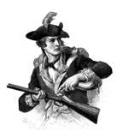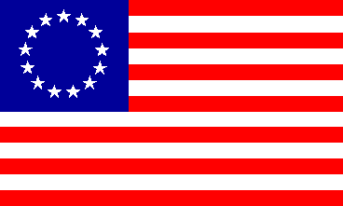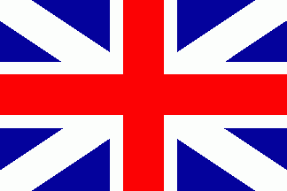

**Important People During the American Revolution**

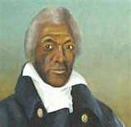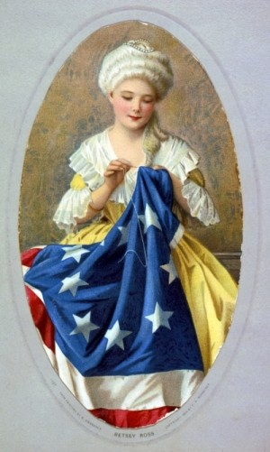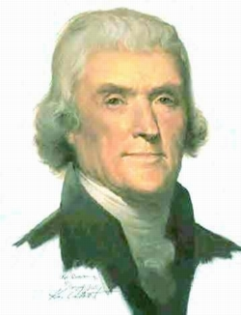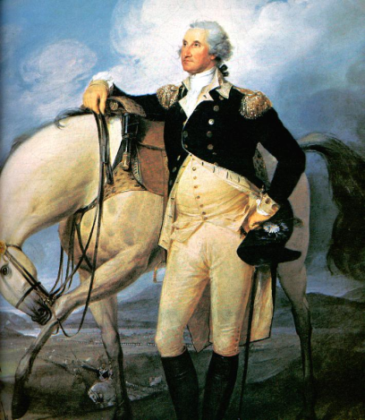C:\Documents and Settings\user\Local Settings\Temporary Internet Files\Content.IE5\LJBY24BP\MC900115855[1].gif

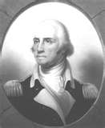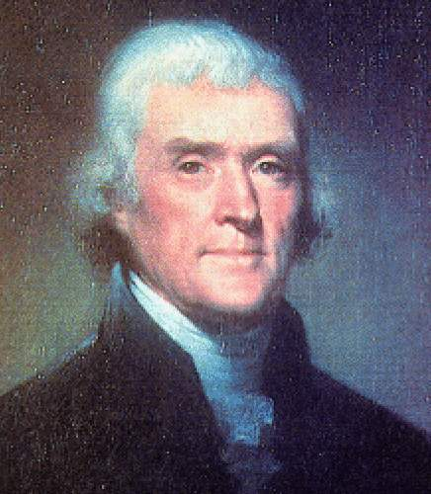C:\Documents and Settings\user\Local Settings\Temporary Internet Files\Content.IE5\LJBY24BP\MC900115855[1].gif

***George Washington*** was the ***Commander of the Continental Army*** during the Revolutionary War. He provided military leadership.

***Thomas Jefferson*** provided political leadership during the Revolutionary War. He expressed the ***reasons for colonial independence*** from England when he wrote the document we know as the ***Declaration of Independence***.

**1**

**2**

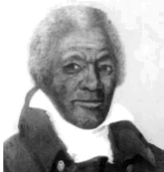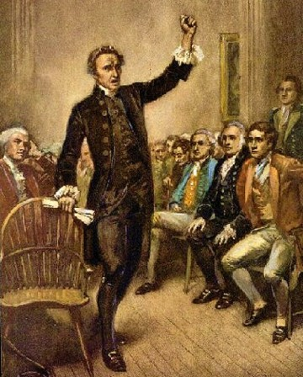C:\Documents and Settings\user\Local Settings\Temporary Internet Files\Content.IE5\LJBY24BP\MC900115855[1].gif

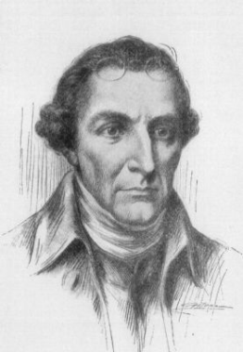

**4**

**3**

***James Armistead Lafayette*** was a ***slave from Virginia***. He ***served in the Continental Army***. Because of his loyal service during the Revolutionary War he was ***given his freedom after the war*** was over.

***Patrick Henry*** inspired patriots from other colonies. He spoke out against ***taxation without representation***. He is most famous for his speech where he spoke the words, ***“Give me liberty or give me death!”***

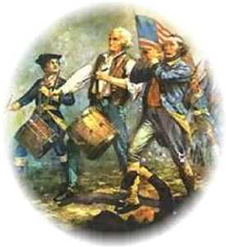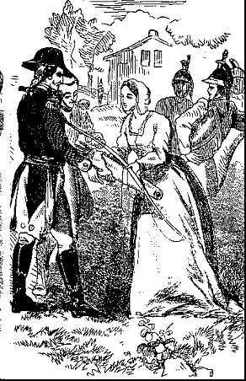C:\Documents and Settings\user\Local Settings\Temporary Internet Files\Content.IE5\LJBY24BP\MC900115855[1].gif

***Women took on many responsibilities*** during the Revolutionary War. Some served as nurses for soldiers and others even worked making ammunition for soldiers.

**6**

**5**

***American Patriots served in the Continental Army.*** They ***fought against the English*** so that America could gain its freedom. Some famous patriots include Patrick Henry, George Washington & Thomas Jefferson.

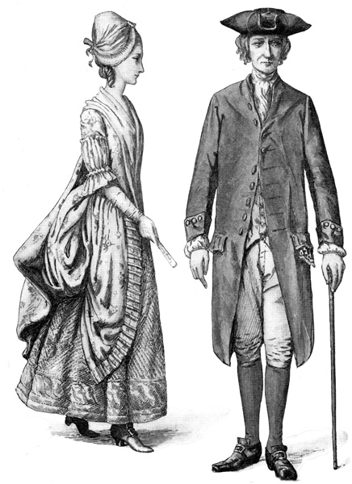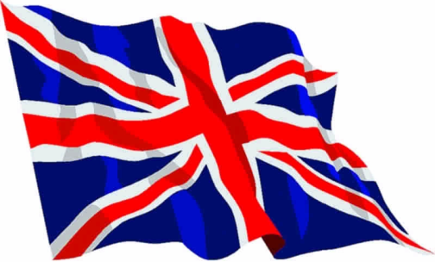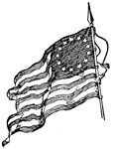C:\Documents and Settings\user\Local Settings\Temporary Internet Files\Content.IE5\LJBY24BP\MC900115855[1].gif

**8**

***Loyalist remained loyal to Great Britain.*** Some Virginians refused to side with the patriots and wanted to support the British.

We must remain loyal to the king.

**7**

***Neutrals did not take sides during the American Revolution.*** Some Virginians decided it was best to be ***neutral*** and ***not take sides***.

**Neither!**

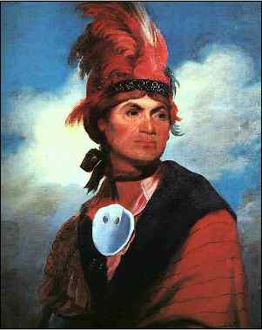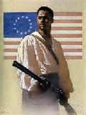C:\Documents and Settings\user\Local Settings\Temporary Internet Files\Content.IE5\LJBY24BP\MC900115855[1].gif

**10**

***American Indians*** were also divided during the war. ***Many fought alongside Virginia patriots*** but ***some*** decided to ***side with the British***.

**9**

***African Americans*** were divided about the war. ***Some slaves fought for the English*** because they were ***promised their freedom*** if they agreed to side with them.